**TO ACKNOWLEDGE EXEMPLARY STUDENTS**

**MINOR PROJECT REPORT**

***Submitted in partial fulfilment of th*e *requirements for the award of the degree***

***of***

**BACHELOR OF TECHNOLOGY**

***in***

**INFORMATION TECHNOLOGY ENGINEERING**

***by***

**Prachi Bhatia Naiya Sehgal Divyam Thapliyal**

**En. No:41715603116 En. No: 40315603116 En. No:35515603116**

***Guided by***

**Mr. Devender Banga**

**Assistant professor**



**DEPARTMENT OF INFORMATION TECHNOLOGY ENGINEERING**

**AKHILESH DAS GUPTA INSTITUTE OF TECHNOLOGY AND MANAGEMENT**

**(AFFILIATED TO GURU GOBIND SINGH INDRAPRASTHA UNIVERSITY, DELHI)**

**NEW DELHI – 110053**

**NOV 2019**

**CANDIDATE’S DECLARATION**

It is hereby certified that the work which is being presented in the B. Tech Minor Project Report entitled **"TO ACKNOWLEDGE EXEMPLARY STUDENTS"** in partial fulfilment of the requirements for the award of the degree of **Bachelor of Technology** and submitted in the **Department of Information Technology Engineering** of **AKHILESH DAS GUPTA INSTITUTE OF TECHNOLOGY AND MANAGEMENT, New Delhi (Affiliated to Guru Gobind Singh Indraprastha University, Delhi)** is an authentic record of our own work carried out during the period from **August 2019 to November 2019** under the guidance of **Mr. Devender Banga, Assistant professor.**

The matter presented in the B. Tech Minor Project Report has not been submitted by me for the award of any other degree of this or any other Institute.

**Prachi Bhatia Naiya Sehgal Divyam Thapliyal**

**En. No:41715603116 En. No: 40315603116 En. No:35515603116**

This is to certify that the above statement made by the candidate is correct to the best of my knowledge. They are permitted to appear in the External Minor Project Examination.

**Mr. Devender Banga Dr. Prashant Singh**

**(Mentor) Head, IT**

**Mr. Ankit Agarwal**  **Dr. Preety Verma Dhaka**

**Project Coordinator Project Coordinator**

**(Signature of External Examiner)**

**ABSTRACT**

To identify exemplary students firstly all the educational institutions need to upload the results of students as well as points/certificates of extra curricular activity (activity name, score out of 10 for performance) to the database for a student according to the current class of study. Aadhar number for all the students will always be given (from there students details will be verified).

A parent or any other non government institute can also upload scanned copy of result or certificate of any student with his/her Aadhar number and their own details. Admin will cross-check and verify it for the update in the database. One’s (schools and institutions) first login or registration, there will be a unique token, (user id and password) to the Portal. That login will be further verified. So every institution will have a unique user id and password and students' details will be uploaded yearly and updates will be done twice in a year.

The second fold of the solution is to sort the data according to the merit of students. The designed application will perform the operation with the provided data and present a lesser (according to requirement) students' details. There will be a faster and optimal Algorithm to sort data by marks and activity score from database .Base will be adopted i.e., tree type-level representation) to sort the data (details) of exemplary students from provided records of all the students.

The third and final part is providing the list of exemplary students to the education department and NGOs. Each official and NGO will also have a login section. The list of exemplary students will be provided according to year, required field. The education department or university can also post the facilities provided to the selected and shortlisted student as a notice.

Therefore, we are going to develop a Web-based application comprising of Web portal and secured database to identify exemplary students in primary education according to data (100%) uploaded and retrieved from several institutions and selected exemplary students list will be provided to the Education Department and Universities.

**ACKNOWLEDGEMENT**

We express our deep gratitude to **Mr Devender Banga**, Assistant professor, Department of Information Technology Engineering for his valuable guidance and suggestions throughout my project work. We are thankful to **Mr. Ankit Agarwal,** Project Coordinator and **Dr. Preety Verma Dhaka**, Project Coordinator for their valuable guidance.

We would like to extend my sincere thanks to **Dr. Prashant Singh, Head of the Department,** for his time to time suggestions to complete my project work.

**Prachi Bhatia Naiya Sehgal Divyam Thapliyal**

**En. No:41715603116 En. No: 40315603116 En. No:35515603116**

**TABLE OF CONTENTS**

|  |
| --- |
| CANDIDATE DECLARATION…………………………….............. i |
| ABSTRACT…………………………………………………………. ii |
| ACKNOWLEDGEMENT…………………………………………....iv |
| TABLE OF CONTENTS……………………………………………..v |

Chapter 1: Introduction

* 1. Introduction

1.1.1Web Development

1.1.2Portal Requirements

1.1.3Software Requirements

1.1.4Web Application Technologies

1.2 Motivation

1.3 Objective

1.4 Summary

Chapter 2 : Working of Technology

2.1 Web Applications

2.1.1 Context of Project

2.2 Technologies Used

2.2.1 Implementation and Software

requirements

2.3 Client Side Technologies

2.4 Server Side Technologies

2.4.1 Working

2.5 Module Description

Chapter 3 : Result and Discussion

Chapter 4 : Conclusion

References

**CHAPTER 1: INTRODUCTION**

**1.1**  **INTRODUCTION**

We are going to make a Web-based application, where the application structure is broken into different fragments, which perform different jobs. One part will be taking in the to the database from a web portal designed using CSS, JavaScript, Node js, mySql. Computation of the sorted data and the various mathematical calculations i.e. arranging the sorted data according to given criteria etc will be done.

Another part will be integrated with the various Education Department and Universities to provide them up with shortlisted meritorious students, integrating with their personal choices and cut-offs, and also where shortlisted students will be notified by notice posted. Keeping in mind the ease of obtaining marks and details which has increased throughout the years.

In the web app, after one's first login or registration, each part of the education department, university and institution have a unique token, (user id and password) to the database. Coming to the part of its database, My SQL can be used with a firmed dashboard powered by JavaScript on a network frame. Since the app will be containing huge academic details of many students, so a strong encryption algorithm will be used for data integrity and data security.

**1.1.1 Web Development**

Web development is a broad term for the work involved in developing a website for the Internet (World Wide Web) or an intranet (a private network). Web development can range from developing the simplest static single page of plain text to the most complex web-based internet applications (or just 'web apps') electronic businesses, and social network services. A more comprehensive list of tasks to which web development commonly refers, may include web engineering, web design, web content development, client liaison, client- side/server-side scripting, web server and network security configuration, and e-commerce development. Among web professionals, "web development" usually refers to the main non-design aspects of building web sites: writing markup and coding.

Web development is the coding or programming that enables website functionality, per the owner's requirements. It mainly deals with the non-design aspect of building websites, which includes coding and writing markup.

Web development ranges from creating plain text pages to complex web-based applications, social network applications and electronic business applications.

The web development hierarchy is as follows:

* Client-side coding
* Server-side coding
* Database technology
* All pages should have unique TITLE to assist screen readers as well as search engines apart from the normal user
* All pages should have META TAGS (Keywords and Description) related to that page
* Clear heading structure (H1, H2 and H3) should be maintained. This helps the visually challenged user to quickly scan the main content heads of the page. There should be  
  only one H1 tag on a page
* Use external CSS as much as possible, avoid inline styling

**1.1.2 Portal Requirements**

We require a platform providing for scalable and extensible architecture for the Portal and supporting key technical and functional requirements.

The requirements include factors such as:

1. Services
2. Service availability
3. Future growth
4. New technologies
5. Capital investment

The requirements address detailed goals and objectives.

The technical requirements (often called functional requirements) include factors such as:

* Performance
* Security
* Reliability
* Expected performance criteria of the portal

**1.1.3 Software requirements**

Client-side Scripting : Programming Language : Database :

HTML, CSS, JavaScript, Ajax, Node.JS, Chart.JS, Express.JS

Visual Studio Code

MySQL

**1.1.4 Web Application Technologies**

HTML (Hypertext Markup Language)

HTML is a text-based approach to describing how content contained within an HTML file is structured. This markup tells a web browser how to display the text, images and other forms of multimedia on a webpage.

The idea of using text to describe how text should be displayed might sound somewhat paradoxical, but it is not. This is the whole reason why HTML is known as a markup language.

CSS (Cascading Style Sheet)Cascading style sheets are used to format the layout of Web pages. They can be used to define text styles, table sizes, and other aspects of Web pages that previously could only be defined in a page's HTML.

CSS helps Web developers create a uniform look across several pages of a Web site. Instead of defining the style of each table and each block of text within a page's HTML, commonly used styles need to be defined only once in a CSS document.

JavaScript

JavaScript is a programming language commonly used in web development. It was originally developed by Netscape as a means to add dynamic and interactive elements to websites. While JavaScript is influenced by Java, the syntax is more similar to C.

Ajax

Ajax code and scripting languages, such as PHP and ASP to access data from a database. Since jQuery runs on the client side (rather than the web server), it can update information on a webpage in real-time, without reloading the page.

MySQL

MySQL, pronounced either "My Sequel," is an open source relational database management system. It is based on the structure query language (SQL), which is used for adding, removing, and modifying information in the database.

Node.js

Node.js brings event-driven programming to web servers, enabling development of fast web servers in JavaScript. Developers can create scalable servers without using threading, by using a simplified model of event-driven programming.

Chart.js

Chart.js is an open source JavaScript library on Github that allows you to draw different types of charts by using the HTML5 canvas element. Since it uses canvas, you have to include a polyfill to support older browsers.

Express.js

Express.js, or simply Express, is a [web application framework](https://en.wikipedia.org/wiki/Web_application_framework) for [Node.js](https://en.wikipedia.org/wiki/Node.js), released as [free and open-source software](https://en.wikipedia.org/wiki/Free_and_open-source_software) under the [MIT License](https://en.wikipedia.org/wiki/MIT_License). It is designed for building [web applications](https://en.wikipedia.org/wiki/Web_application) and [APIs](https://en.wikipedia.org/wiki/API). It has been called the [de facto standard](https://en.wikipedia.org/wiki/De_facto_standard) server framework for [Node.js](https://en.wikipedia.org/wiki/Node.js).

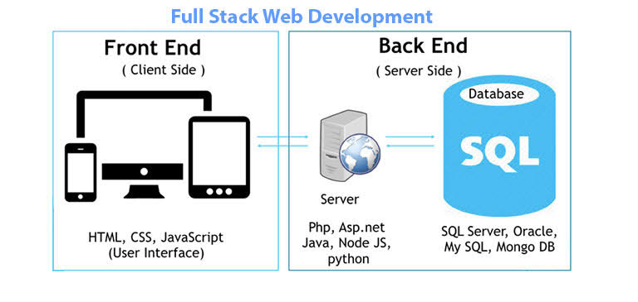 Fig 1.1 Full stack web development

**1.2 MOTIVATION**

There are 29 states in India. Each state has different cities and villages across India. There is no mechanism to identify bright students who are performing well in studies, sports or other activities. Web-portal can be designed to acquire data about such students and can be analyzed on different parameters.

What Exact Problem is being solved?

Such identified students can be provided with extra resources or special attention can be given to their upbringing.

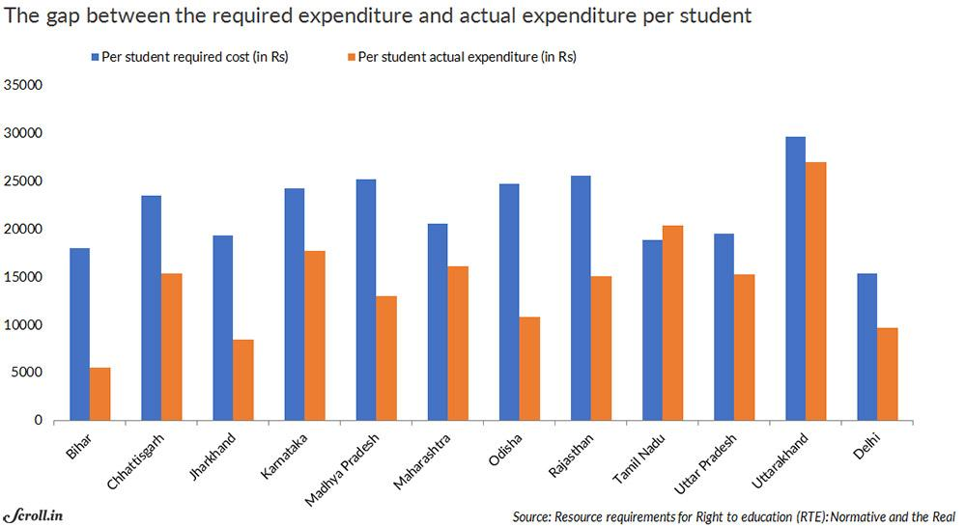

Fig 1.2 Graph showing gap between required and actual expenditure per student

**1.3 OBJECTIVE**

* Identification of poor exemplary students and Funding based support from different NGOs, organizations and donations if they want to provide.
* Choice Based selection of such students from data set. For instance,if the requirement is only limited to academics, they can refer to the website to fetch a list of top scorers say top 100 or top 200 students.
* Again if the requirement is limited to selection of Extra-curricular activity like – singing, painting, dancing etc they can fetch the list of students having expertise in that particular field only.
* To highlight the social issues such as child labour, child trafficking, by year wise regulation data.
* School wise progress analysis using pie charts and bar graphs.
* Update records every year to keep a check on the improvement, standardization & sorting data based to filter out the exemplary students on the basis of academics and extra curricular activities.
* The school should submit their data to get a recognition as well as to be in sight of fund providing parties (governmental or non-governmental).
* Students will be benefited as direct communication is in between officials and student and no middle man in between.

**1.4 SUMMARY**

The project is aimed to provide a central place for all the educational institutions, government and NGOs to provide them with necessary information and in order to improve and promote the education sector in the country.

It is, therefore, a web application that should be compatible with majority of browsers to provide user friendly interface. The web enabled information management system is designed to provide opportunity to the NGOs to enroll themselves on the portal in order to get all the data and partner accordingly.

The application is divided into frontend and backend using web development technologies to build up a dashboard for government officials and NGOs where a detailed analysis using search based lists and graphs is maintained.

EduGo locks together sector planning and implementation, government-led dialogue and monitoring, and education financing, to enable NGOs to achieve their goals in learning and equity. This reflects on the support provided, and learn from the results achieved to date, to ensure that meaningful and equitable changes happen at a certain level.

Our monitoring and evaluation takes place within the framework. The purpose of this strategy is to generate data and evidence that help the partners learn, improve what it does, and be accountable to its constituents. EduGo provides with shortlisted meritorious students and integrate their personal choices and cut-offs.

**CHAPTER 2: WORKING OF TECHNOLOGIES**

**2.1 WEB APPLICATION**

The application had been planned to consist of two parts, front-end and back-end development. The front-end is the part of the web that you can see and interact with (e.g. Client-side programming). While front-end code interacts with the user in real time, the back-end interacts with a server to return user ready results. The front-end is a combination of HTML, CSS, JavaScript and jQuery coding. By using JavaScript, modifications of the design of a web page can be made immediately, however only temporary and visible only by the user.

Normally the user would not have rights to modify web content dynamically on the server side. Logically, administrators are the ones who deal with back-end modification of databases for example, as they often contain sensitive data which should not be available to see or modify by the general public. Back-end programming language in this project is Java. The code built by using java is more reliable.

Signals to users in order to provide positioning, navigation, and timing. Global civil GPS service has been available worldwide since 1993, continuously and free of direct user fees. Both our generation and economy depend on technological infrastructure and GPS, yet GPS signals are vulnerable to intentional and unintentional disruption.

Communications, energy, emergency, transportation and space satellite deployment all depend on GPS, and the loss of GPS signals could have unimaginable impacts on our society. Over the past few years, the US government has started upgrading GPS space satellites with new features through a multi-billion-dollar effort to improve the overall performance of GPS.

**2.1.1 Context of Project**

EduGo supports developing country governments to develop good quality education sector plans. Governments take the lead in planning and are accountable for delivery, this enables needs analysis, works to strengthen technical capacity, and brings in the talent and resources of all partners.

We support areas with the greatest needs, and the children and youth most often left behind and nations with high numbers of out-of-school children and weak school completion rates. Also, we focus on reaching the children that are most marginalized and vulnerable including [girls](https://www.globalpartnership.org/focus-areas/girls-education), [children with disabilities](https://www.globalpartnership.org/focus-areas/children-with-disabilities). We mobilize financing from public and private sources around the world and encourages developing country partners to provide sufficient domestic financing for basic education.

In this Project Report, there is an overall description of the Web Project. The system is an online application that can be accessed by the government officials and NGOs as well.

The objectives for this project are:

1. Research the problem and choose a development methodology to follow.
2. Establish a list of user requirements.
3. Design a web application to incorporate the requirements of the user

**2.2 TECHNOLOGIES USED**

For the completion of the tasks, the following web languages and scripts have been used:

* HTML for the construction of the layout
* CSS for the design of the layout
* JavaScript for dynamic functioning
* jQuery for event handling and animations
* Node.js to build scalable network application.
* Express is a minimal and flexible Node.js web application framework that provides a robust set of features for web and mobile applications.

**2.2.1 Implementation and software requirements**

Before implementing the technologies, we have tips to be followed:

* Always use OPTIMIZED images. Images can be optimized by using image editing  
  software’s.
* Page should have a clear contrast between foreground and background.
* A "Skip to content" link must be provided at the top of the page. This helps the user to  
  directly go to the main content of the page bypassing the repetitive sections like page  
  header, navigations etc.
* All functionality of the content like links, menus, forms etc should be operable through  
  a keyboard interface as the visually challenged cannot use the mouse
* Tables must not be used for layout and presentation purposes. When used for representing data, tables should be provided with proper header row and captions and  
  the data items should flow left to right, one line at a time
* Frames should be avoided while designing a webpage as frames cannot be easily read  
  by the visually impaired. When used, frames should be titled with text that facilitates  
  frame identification and navigation
* Attributes of color, shape and size must not be used to represent information as these  
  would make the content inaccessible to the visually challenged. For example, we  
  should avoid using statements like "All the text written in red are mandatory"
* All script functions should include a NOSCRIPT tag for those browsers or assistive  
  technologies that do not have script support.
* Enough time should be provided to the user to read and interact with content. In case,  
  content is time-based, same should be informed to user in advance
* Website must clearly reflect the ownership of Government of India. Complete linage of the owner department must be mentioned, preferably at the footer of the page.
* Content must be written from citizen's perspective and the language must be simple and  
  free from errors.
* Multilingual versions of the sites must be in sync with each other
* Website must work well in all the major browsers.

Few tricks that can help with implementation,

Using semantically correct markup

HTML was not designed with display considerations in mind. It focused solely on the structural logic of documents and ignored the need for the visual logic of graphic design and typography. HTML is used to create structured documents by denoting structural semantics for text such as headings, paragraphs, lists, links and other items. Structural elements available in HTML should be used for their specific purpose; like heading tag should not be used as a means to format something that is not a heading.

Designing accessible and usable forms

Online forms are becoming an integral part of any government website and it is important that they are dealt with care as poorly designed forms without proper instructions will cause the user to commit mistakes and finally put him off the activity.

Promoting your website

Website promotion is the continuing process to promote a website to bring more visitors to the website. Many techniques such as web content development, search engine optimization and search engine submission, are used to increase the traffic to a site.

Providing meaningful alternate descriptions for non text elements

Meaningful text descriptions must be provided for non text elements like images by giving an ALT tag. For decorative images like icons, bullets etc. a null ALT must be given (ALT=" ") as Screen readers ignore images without alt text. A video presentation with an audio component requires captioning. The captioning must be completely synchronized with the audio presentation to allow for the viewer to follow the meaning of the content. If there is a slide show like a PowerPoint slide show available but it is "visual only", the graphics need to have alternative text representations.

Creating accessible tables

Use tables for representing tabular data only. Take care of following points while

creating tables:

* Provide Names or Titles for Data Tables using the tag.
* Brief summaries of complex data may be given using the summary Attribute.
* Designate Row and Column Headers Using the tag.
* After creating headers, associate the cells with the appropriate headers. You can do  
  so by using the scope attribute (for simple data tables) or use the headers and id  
  attributes (for complex tables).
* Avoid spanned rows and columns as they are not handled well by some screen  
  readers.
* Though images add life to a website, they also increase downloading time. Images should only be used when it adds value to the content. Images should not be used to present text in an alternative style as those using text only browsers shall not be able to access the information thus rendering the site inaccessible to many. Images should be created in an appropriate format to minimize load time and maximize the display quality. There are three formats for displaying images in web browsers - GIF, JPEG and PNG. Use:
* GIF format for images that contain line-art and flat areas of color such as icons and graphs
* JPEG format for images that contain many color variations, such as photographs. JPEG images can contain up to 16 million colors. Also, the size of image files should be reduced as much as possible to minimize the download time of web pages. A variety of techniques can improve the download time of pages:
* Scaling of images should be avoided as they tend to distort. Instead a correct size should be prepared in image processing software.
* A thumbnail (a smaller version) for a large image and link to the full-size copy should be provided where appropriate.

**Visual Studio Code**

Visual Studio Code is an [IDE](https://en.wikipedia.org/wiki/Integrated_development_environment) developed by [Microsoft](https://en.wikipedia.org/wiki/Microsoft) for [Windows](https://en.wikipedia.org/wiki/Windows), [Linux](https://en.wikipedia.org/wiki/Linux) and [macOS](https://en.wikipedia.org/wiki/MacOS).It includes support for [debugging](https://en.wikipedia.org/wiki/Debugging), embedded [Git](https://en.wikipedia.org/wiki/Git) control and [GitHub](https://en.wikipedia.org/wiki/GitHub), [syntax highlighting](https://en.wikipedia.org/wiki/Syntax_highlighting), [intelligent code completion](https://en.wikipedia.org/wiki/Intelligent_code_completion), [snippets](https://en.wikipedia.org/wiki/Snippet_(programming)), and [code refactoring](https://en.wikipedia.org/wiki/Code_refactoring). It is highly customizable, allowing users to change the [theme](https://en.wikipedia.org/wiki/Theme_(computing)), [keyboard shortcuts](https://en.wikipedia.org/wiki/Keyboard_shortcut), preferences, and install [extensions](https://en.wikipedia.org/wiki/Plug-in_(computing)) that add additional functionality. The source code is [free and open source](https://en.wikipedia.org/wiki/Free_and_open_source) and released under the permissive [MIT License](https://en.wikipedia.org/wiki/MIT_License).The compiled binaries are [freeware](https://en.wikipedia.org/wiki/Freeware) and free for private or commercial use.

Visual Studio Code is based on [Electron](https://en.wikipedia.org/wiki/Electron_(software_framework)), a framework which is used to deploy [Node.js](https://en.wikipedia.org/wiki/Node.js) applications for the desktop running on the [Blink layout engine](https://en.wikipedia.org/wiki/Blink_layout_engine). Although it uses the Electron framework,the software does not use [Atom](https://en.wikipedia.org/wiki/Atom_(text_editor)) and instead employs the same editor component (codenamed "Monaco") used in [Azure DevOps](https://en.wikipedia.org/wiki/Azure_DevOps) (formerly called Visual Studio Online and Visual Studio Team Services).

**2.3** **CLIENT SIDE TECHNOLOGIES**

HTML (Hypertext Markup Language)

HTML is a text-based approach to describing how content contained within an HTML file is structured. This markup tells a web browser how to display the text, images and other forms of multimedia on a webpage.

The idea of using text to describe how text should be displayed might sound somewhat paradoxical, but it is not. This is the whole reason why HTML is known as a markup language.

Using HTML, a document containing text is further marked up with additional text describing how the document should be displayed. To keep the markup part separate from the actual content of the HTML file, there is a special, distinguishing HTML syntax that is used. These special components are known as HTML tags. The tags can contain name-value pairs known as attributes, and a piece of content that is enclosed within a tag is referred to as an HTML element. Browsers do not display the HTML tags, but use them to render the content of the page.

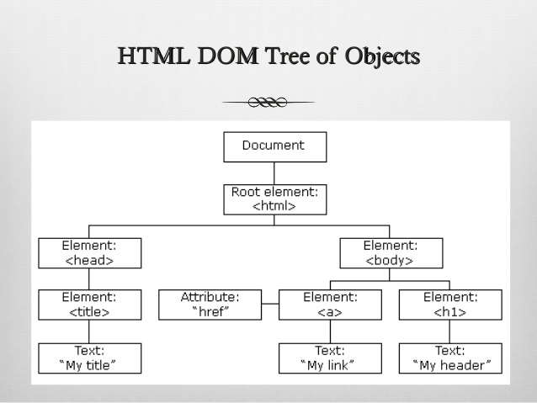

Fig 2.1 HTML DOM tree of objects

CSS (Cascading Style Sheet)

Cascading style sheets are used to format the layout of Web pages. They can be used to define text styles, table sizes, and other aspects of Web pages that previously could only be defined in a page's HTML.

CSS helps Web developers create a uniform look across several pages of a Web site. Instead of defining the style of each table and each block of text within a page's HTML, commonly used styles need to be defined only once in a CSS document. Once the style is defined in cascading style sheet, it can be used by any page that references the CSS file. Plus, CSS makes it easy to change styles across several pages at once.

CSS gives Web developers more exact control over how Web pages will look than HTML does. This is why most Web pages today incorporate cascading style sheets.

HTML was never intended to contain tags for formatting a web page. Development of large websites, where fonts and color information were added to every single page, became a long and expensive process. To solve this problem, the World Wide Web Consortium (W3C) created CSS. CSS removed the style formatting from the HTML page.

JavaScript

JavaScript is a programming language commonly used in web development. It was originally developed by Netscape as a means to add dynamic and interactive elements to websites. While JavaScript is influenced by Java, the syntax is more similar to C.

JavaScript is a client-side scripting language, which means the source code is processed by the client's web browser rather than on the web server. This means JavaScript functions can run after a web page has loaded without communicating with the server. For example, a JavaScript function may check a web form before it is submitted to make sure all the required fields have been filled out. The JavaScript code can produce an error message before any information is actually transmitted to the server.

JavaScript code remains fully visible in the source of the webpage. It can also be referenced in a separate .JS file, which may also be viewed in a browser.

JavaScript functions can be called within <script> tags or when specific events take place. While standard JavaScript is still used for performing basic client-side functions, many web developers now prefer to use JavaScript libraries like jQuery to add more advanced dynamic elements to websites.

Ajax

jQuery is a JavaScript library that allows web developers to add extra functionality to their websites. It is open source and provided for free under the MIT license. In recent years, jQuery has become the most popular JavaScript library used in web development.

<scripttype="text/javascript" src="//ajax.googleapis.com/ajax/libs/jquery/1.9.1/jquery.min.js"></script>

Once the jQuery library is loaded, a web page can call any jQuery function supported by the library. Common examples include modifying text, processing form data, moving elements on a page, and performing animations. jQuery can also work with Ajax code and scripting languages, such as PHP and ASP to access data from a database. Since jQuery runs on the client side (rather than the web server), it can update information on a webpage in real-time, without reloading the page. A common example is "autocomplete," in which a search form automatically displays common searches as you type your query.

Besides its free license, the other main reason jQuery has gained such popularity is its cross-browser compatibility. Since each browser renders HTML, CSS, and JavaScript differently, it can be difficult for a web developer to make a website appear the same across all browsers. Instead of having to write custom functions for each browser, a web developer can use a single jQuery function that will work in Chrome, Safari, Firefox, and Internet Explorer. This multi-browser support has led many developers to switch from standard JavaScript to jQuery, since it greatly simplifies the coding process.

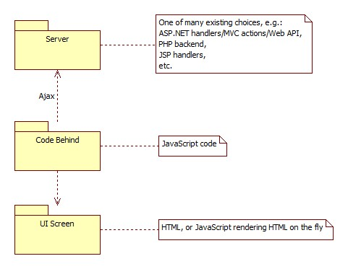

Fig 2.2 Javascript Architecture

|  |  |
| --- | --- |
| MySQL  MySQL, pronounced either "My S-Q-L" or "My Sequel," is an open source relational database management system. It is based on the structure query language (SQL), which is used for adding, removing, and modifying information in the database. Standard SQL commands, such as ADD, DROP, INSERT, and UPDATE can be used with MySQL.  MySQL can be used for a variety of applications, but is most commonly found on Web servers. A website that uses MySQL may include Web pages that access information from a database. These pages are often referred to as "dynamic," meaning the content of each page is generated from a database as the page loads. Websites that use dynamic Web pages are often referred to as database- driven websites.  Many database-driven websites that use MySQL also use a Web scripting language like PHP to access information from the database. MySQL commands can be incorporated into the PHP code, allowing part or all of a Web page to be generated from database information. Because both MySQL and PHP are both open source (meaning they are  free to download and use), the PHP/MySQL combination has become a popular choice for database-driven websites.    Fig 2.3 SQL Architecture  **2.3.2 Working**  Web pages are developed using HTML where CSS is used for styling and JavaScript libraries like jQuery are used to add more advanced dynamic elements to web pages.  The homepage of EduGo contains various web pages linked to it such as login page which allow the government officials to login and NGOs can login after registering with EduGo. A unique login ID is generated which allows them to login. Schools can login and upload the data of students enrolled with them in the form of .csv file.  Insights provide government and NGOs a dashboard where they can look for data and a detailed analysis is provided based on their input in the form of lists and graphs. School results provide a comparison in the form of visual data for the different schools enrolled with us.  **2.4**   **SERVER-SIDE TECHNOLOGIES**   |  | | --- | | Node.js  Node.js is an open-source, cross-platform JavaScript run-time environment that executes JavaScript code outside of a browser. Node.js lets developers use JavaScript to write command line tools and for server-side scripting—running scripts server-side to produce dynamic web page content before the page is sent to the user's web browser. Consequently, Node.js represents a "JavaScript everywhere" paradigm, unifying web application development around a single programming language, rather than different languages for server- and client-side scripts.  Though .js is the standard filename extension for JavaScript code, the name "Node.js" does not refer  to a particular file in this context and is merely the name of the product. Node.js has an event-driven architecture capable of asynchronous I/O. These design choices aim to  optimize throughput and scalability in web applications with many input/output operations, as well as for real-time Web applications.  Fig 2.4 Functions of Node JS | |
|  |

Node.js brings event-driven programming to web servers, enabling development of fast web servers in JavaScript. Developers can create scalable servers without using threading, by using a simplified model of event-driven programming that uses callbacks to signal the completion of a task. There are

thousands of open-source libraries for Node.js, most of them hosted on the

npm” website.

Benefits of using node.js are:

✓ Node.js offers an easy scalability

✓ Easy to learn

✓ Node.js is used as a single programming language

✓ Known for offering high performance

✓ Node.js is highly extensible

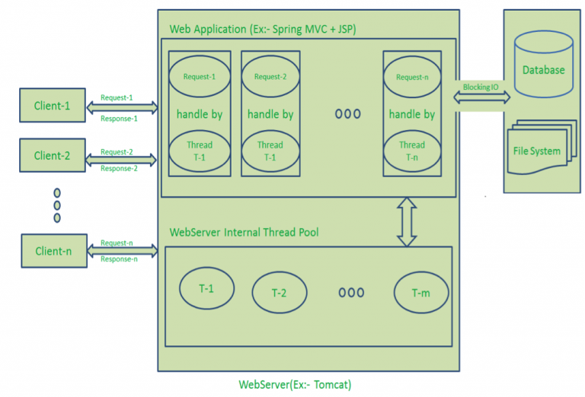

Fig 2.5 Node JS Architecture

Chart.js

Chart.js is an open source JavaScript library on Github that allows you to draw different types of charts by using the HTML5 canvas element. Since it uses canvas, you have to include a polyfill to support older browsers.

The HTML5 element gives an easy and powerful way to draw graphics using JavaScript. It can be used to draw graphs, make photo compositions or do simple (and not so simple) animations.

It is responsive in nature that means it redraws chart on resizing of window for perfect scale granularity.

This library supports 8 different types of graphs :

1. Line

2. Bar

3. Doughnut

4. Pie

5. Radar

6. Polar Area

7. Bubble

8. Scatter

Chart.js is a community maintained open-source library that helps you easily visualize data using JavaScript. It’s similar to Chartist and Google Charts. It supports 8 different chart types , and they’re all responsive. In other words, you set up your chart once, and Chart.js will do the heavy-lifting for you and make sure that it’s always legible (for example by removing some uncritical details if the chart gets smaller).

Bar Chart :

Bar charts are (mostly) just line charts that look a bit different. By changing one line of our previous example, we can create a bar chart.

Pie & Doughnut Charts :

A pie chart (or a circle chart) is a circular statistical graphic, which is divided into slices to illustrate numerical proportion. Express.js tutorial provides basic and advanced concepts of Express.js. Our Express.js tutorial is designed for beginners and professionals both.

Express,js

Express.js is a web framework for Node.js. It is a fast, robust and asynchronous in nature.

Our Express.js tutorial includes all topics of Express.js such as Express.js installation on windows and linux, request object, response object, get method, post method, cookie management, scaffolding, file upload, template etc.

Express is a fast, assertive, essential and moderate web framework of Node.js. You can assume express as a layer built on the top of the Node.js that helps manage a server and routes. It provides a robust set of features to develop web and mobile applications.

Let's see some of the core features of Express framework:

* It can be used to design single page, multi page and hybrid web applications.
* It allows to setup middlewares to respond to HTTP Requests.
* It defines a routing table which is used to perform different actions based on HTTP method and URL.
* It allows to dynamically render HTML Pages based on passing arguments to templates.
* Ultra fast I/O
* Asynchronous and single threaded
* MVC like structure
* Robust API makes routing easy

**2.4.1 Working**

The data that is input of all the schools, government and NGOs is handled at the backend. Registration details are saved on database and a unique Id is generated that allows user to login.

The dashboard allows to search from the data that has been uploaded and entered by the schools in the form of .csv file and using node.js a list of students is generated which provides the government and NGOs with the desired number of students by applying various filters based on the name of the school, class, year, grade in extracurricular activities and percentage in academics.

For visual analysis and statistics, Chart.js is used to present the data in the form of bar graphs and pie charts. These charts will be formed based on the input from government and NGOs in the form of schools and year.

**2.5 MODULE DESCRIPTION**

We support government to develop good quality education sector plans. Governments take the lead in planning and are accountable for delivery; this enables needs analysis, works to strengthen technical capacity, and brings in the talent and resources of all partners.

We support areas with the greatest needs, and the children and youth most often left behind and nations with high numbers of out-of-school children and weak school completion rates. Also, we focus on reaching the children that are most marginalized and vulnerable including [girls](https://www.globalpartnership.org/focus-areas/girls-education), [children with disabilities](https://www.globalpartnership.org/focus-areas/children-with-disabilities).

Schools will upload the details of their students and their information on the portal and after the evaluation of the data, results will be generated accordingly.

We have to create a platform which provides all the necessary information to the government and NGOs. Platform must consist of the details of the analysis and other facilities that are provided to the NGOs as well.

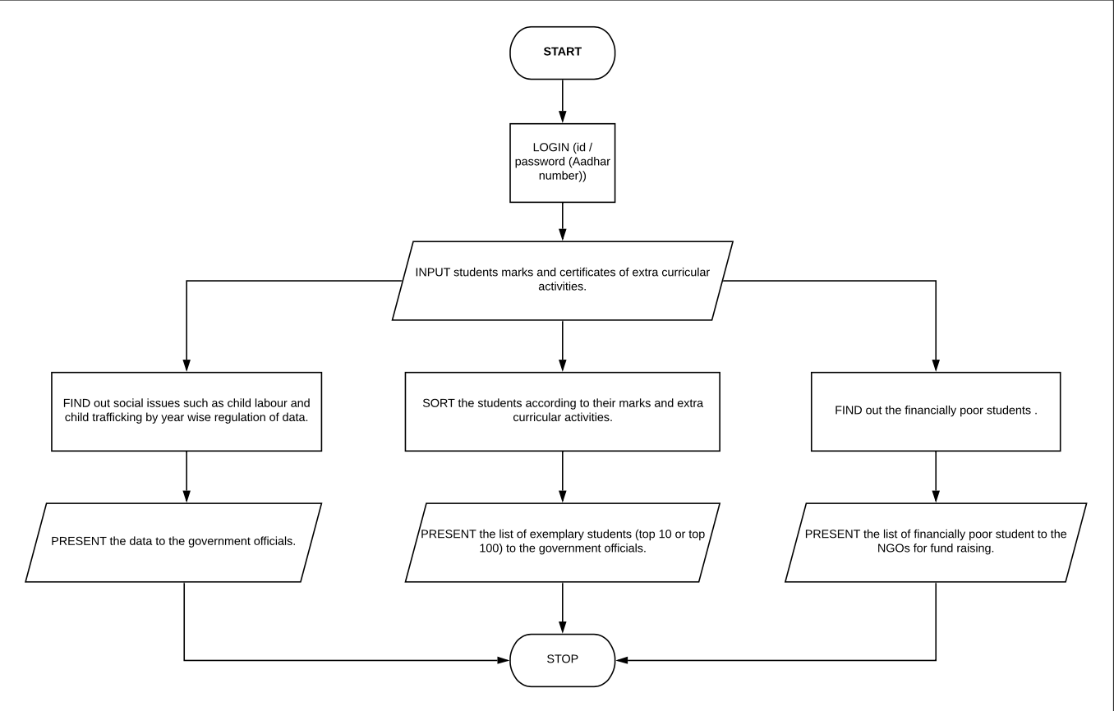

Fig 2.6 Flowchart of the application

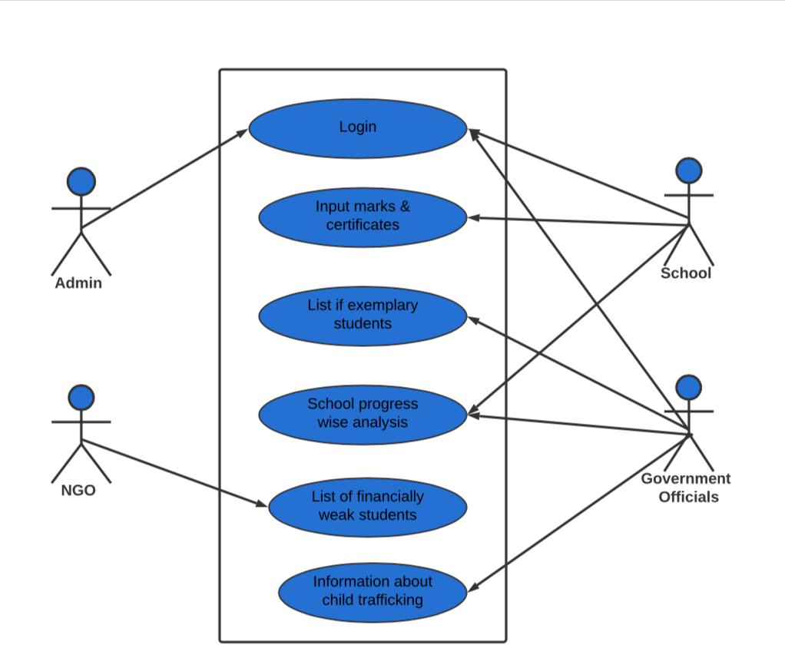 Fig 2.7 Use case diagram of the project

**CHAPTER 3: RESULTS AND DISCUSSION**

Web pages are developed using HTML where CSS is used for styling and JavaScript libraries like jQuery are used to add more advanced dynamic elements to web pages.

The homepage of EduGo contains various web pages linked to it such as login page which allow the government officials to login and NGOs can login after registering with EduGo. A unique login ID is generated which allows them to login. Schools can login and upload the data of students enrolled with them in the form of .csv file.

Insights provide government and NGOs a dashboard where they can look for data and a detailed analysis is provided based on their input in the form of lists and graphs. School results provide a comparison in the form of visual data for the different schools enrolled with us.

The data that is input of all the schools, government and NGOs is handled at the backend. Registration details are saved on database and a unique Id is generated that allows user to login.

The dashboard allows to search from the data that has been uploaded and entered by the schools in the form of .csv file and using node.js a list of students is generated which provides the government and NGOs with the desired number of students by applying various filters based on the name of the school, class, year, grade in extracurricular activities and percentage in academics.

For visual analysis and statistics, Chart.js is used to present the data in the form of bar graphs and pie charts. These charts will be formed based on the input from government and NGOs in the form of schools and year.

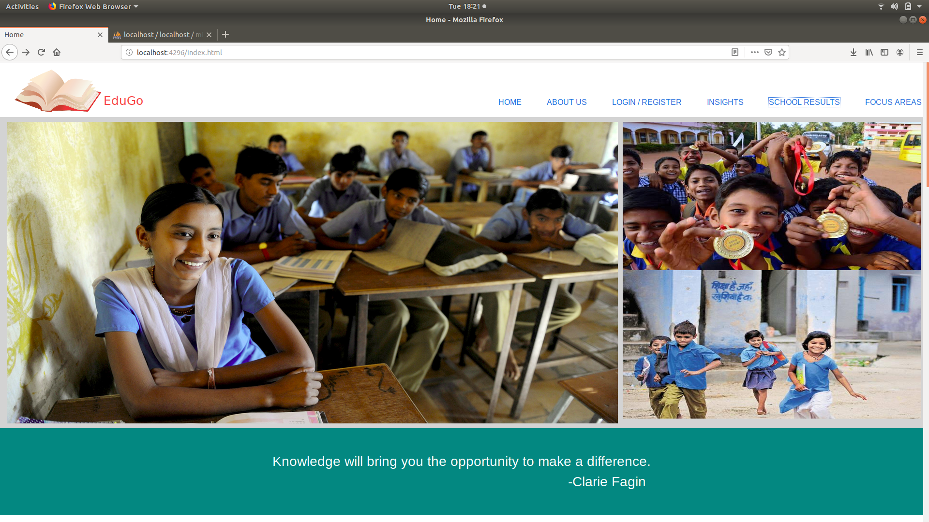

Fig 3.1 Homepage of EduGo

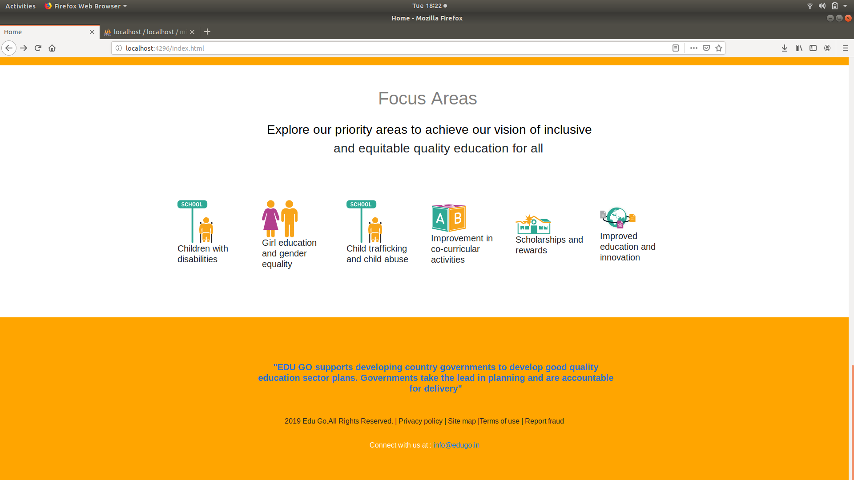

Fig 3.2 Footer of Homepage

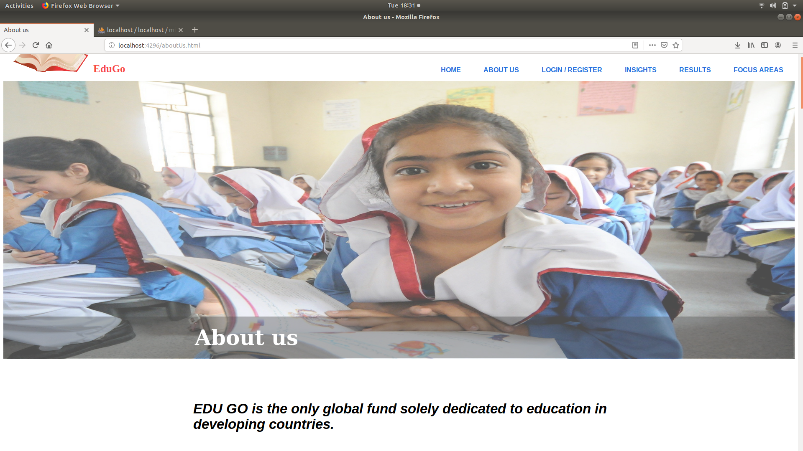

Fig 3.3 About EduGo

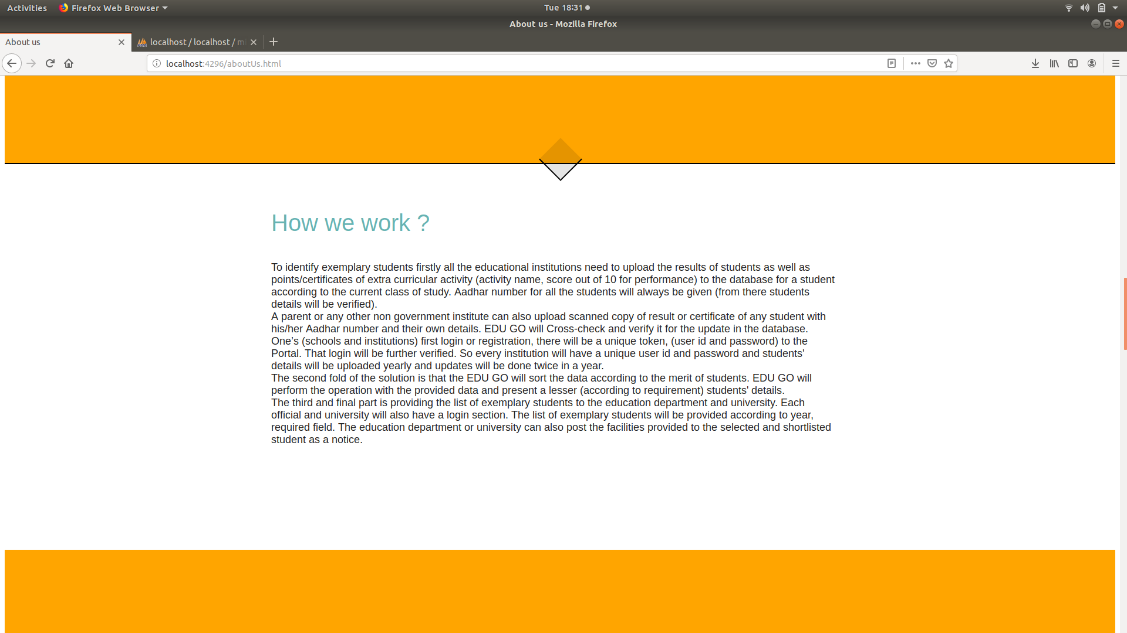

Fig 3.4 Working of EduGo

 Fig 3.5 Focus areas of EduGo

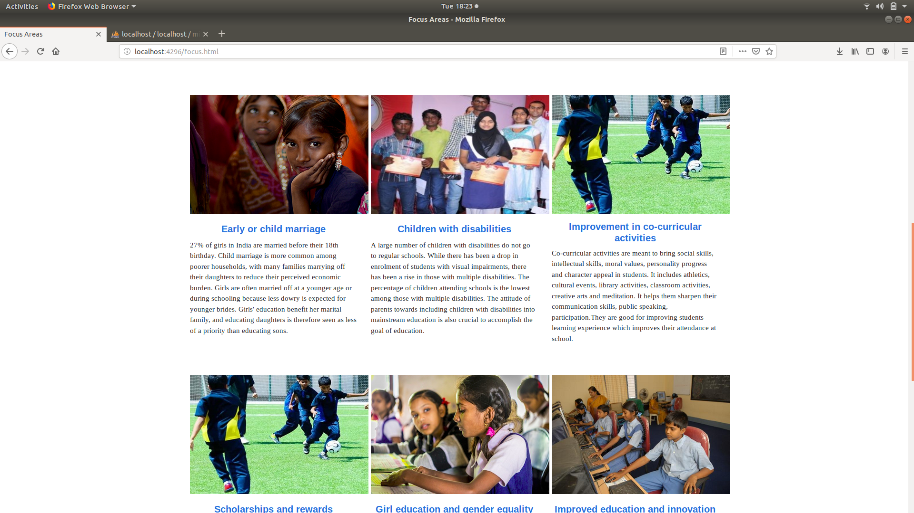

Fig 3.6 Issues handled by EduGo

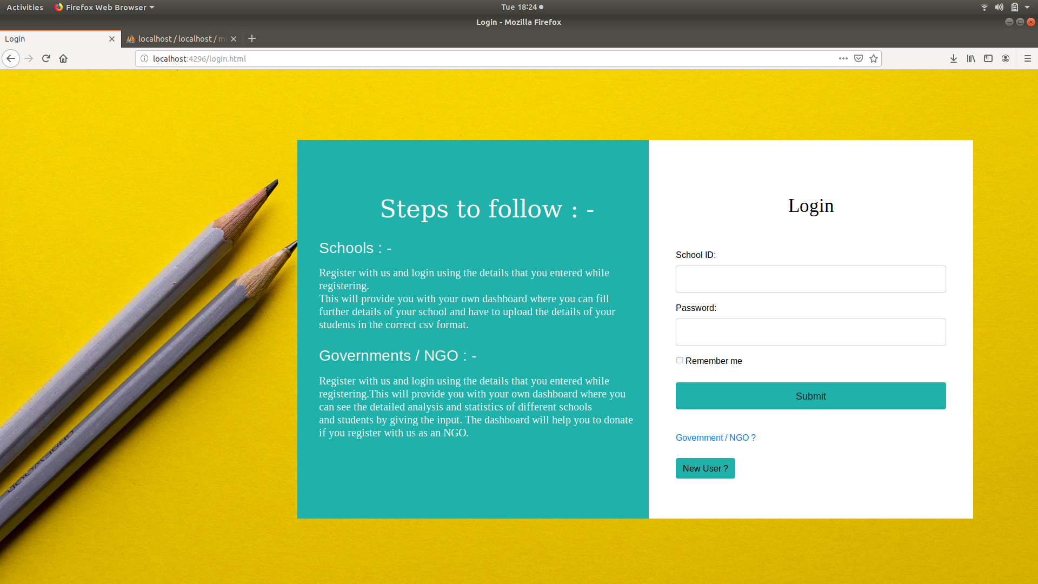

Fig 3.7 Login page of EduGo

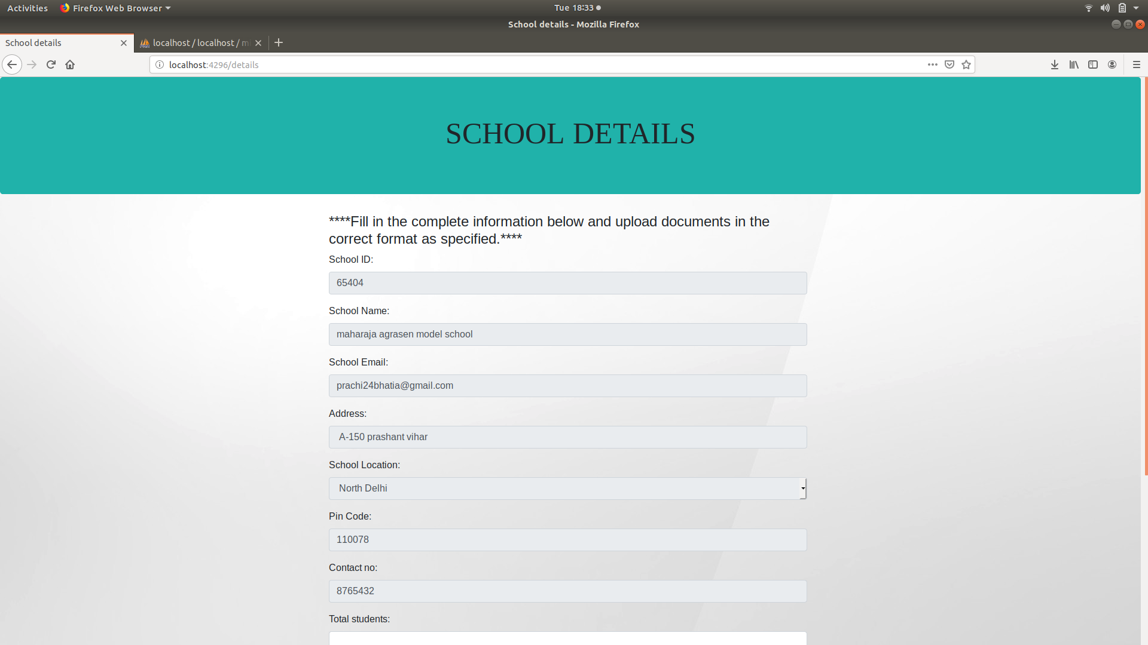

Fig 3.8 Data entry by schools at EduGo

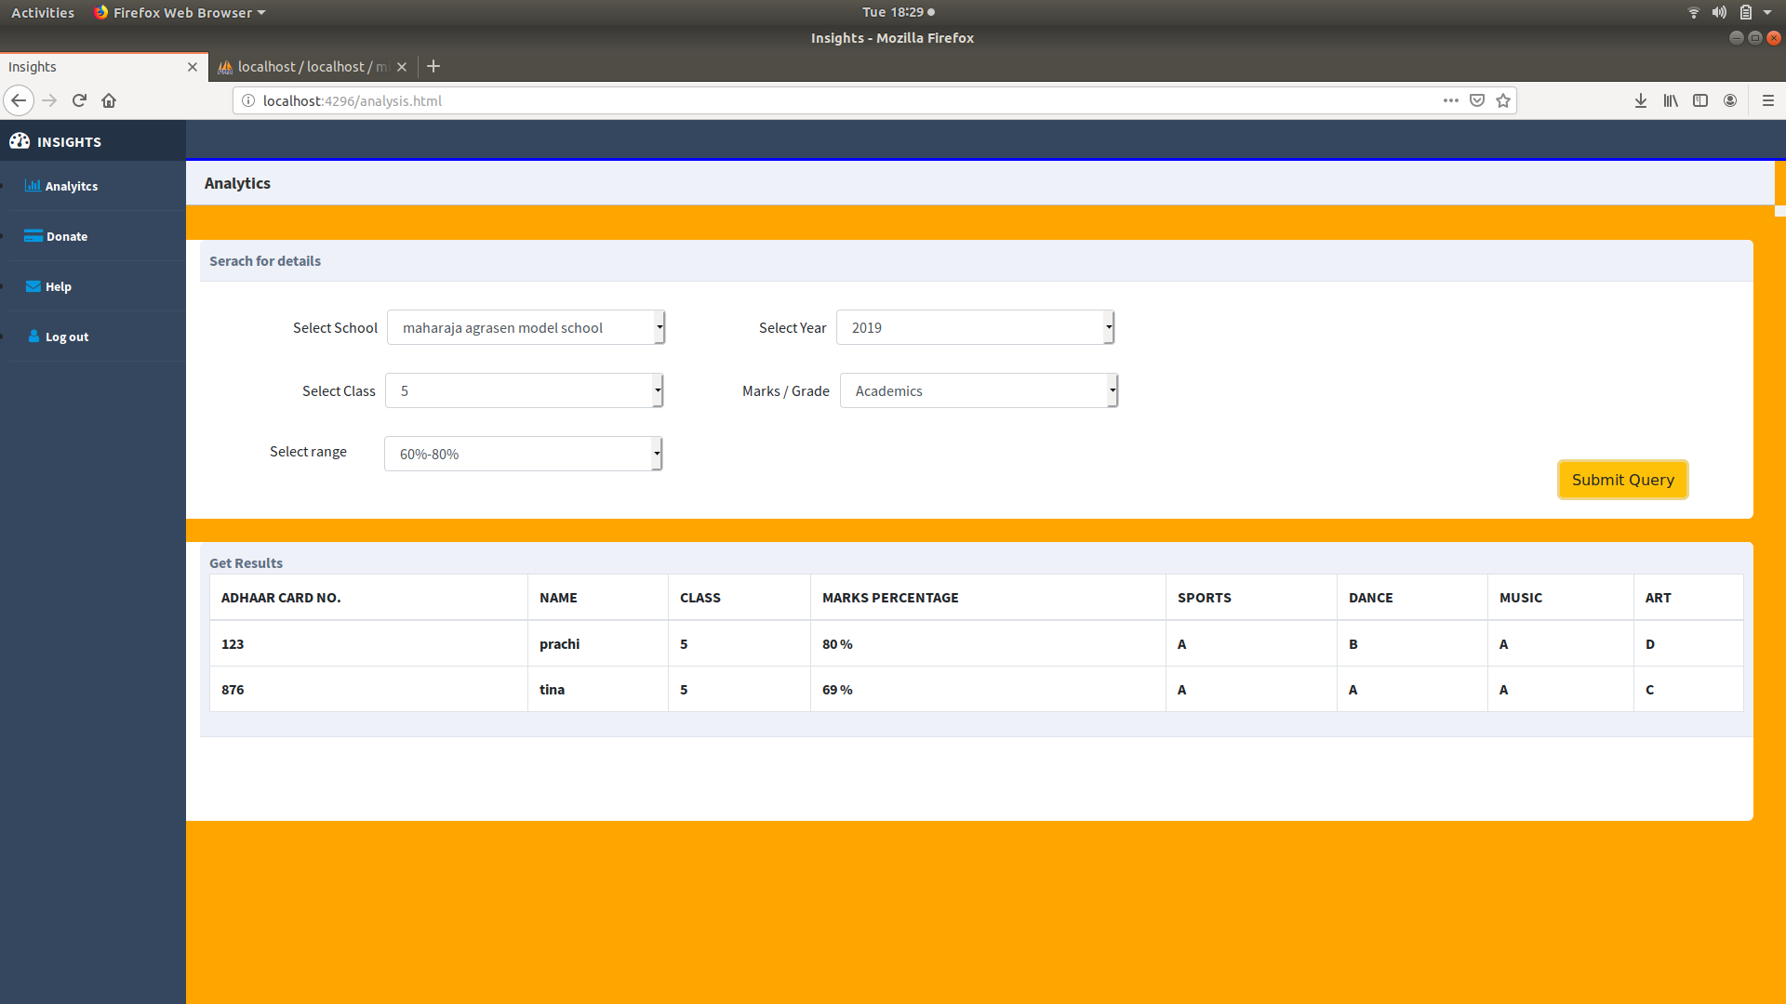

Fig 3.9 Dashboard for government officials

 Fig 3.10 Table of results at dashboard

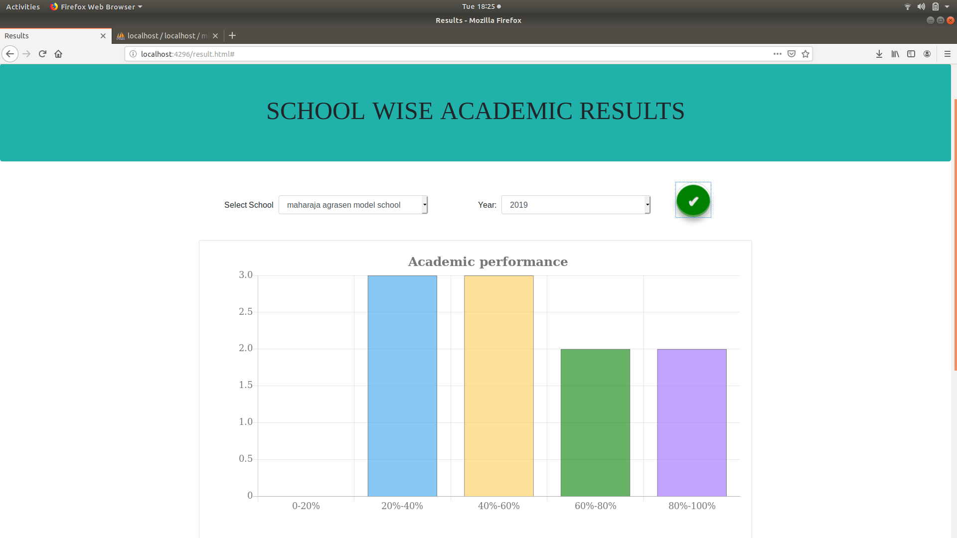

Fig 3.11 Bar Graph based on data entered

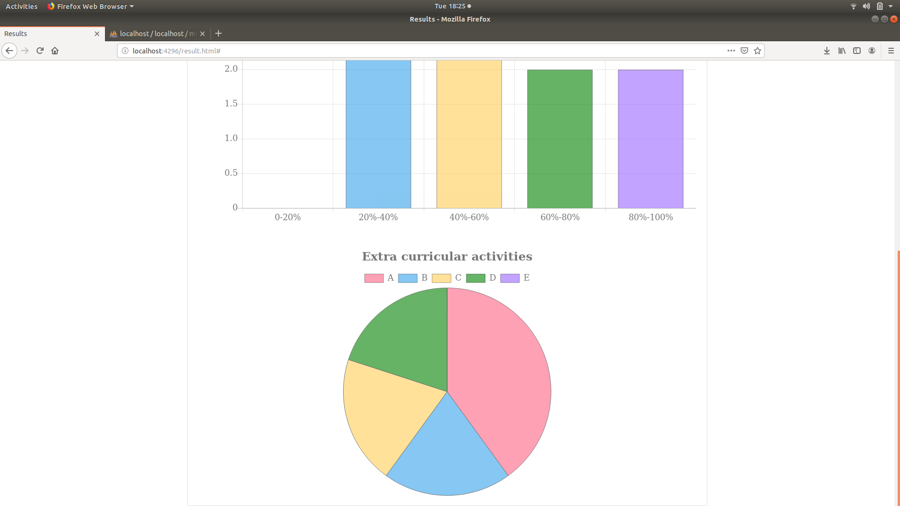 Fig 3.11 Pie chart based on data entered

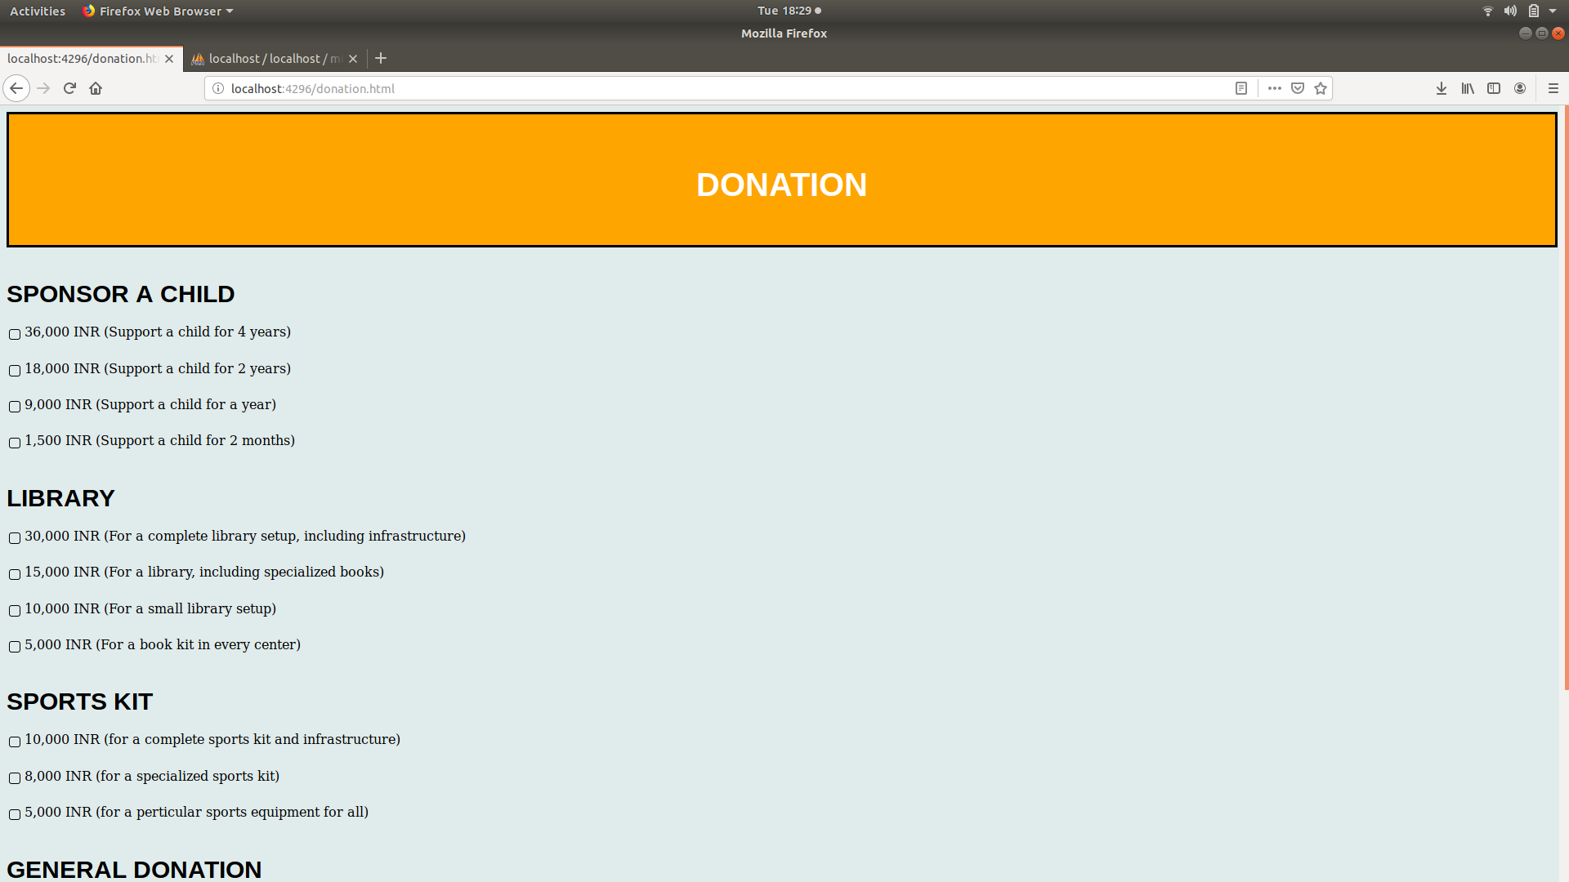

Fig 3.12 Donation for schools through NGOs

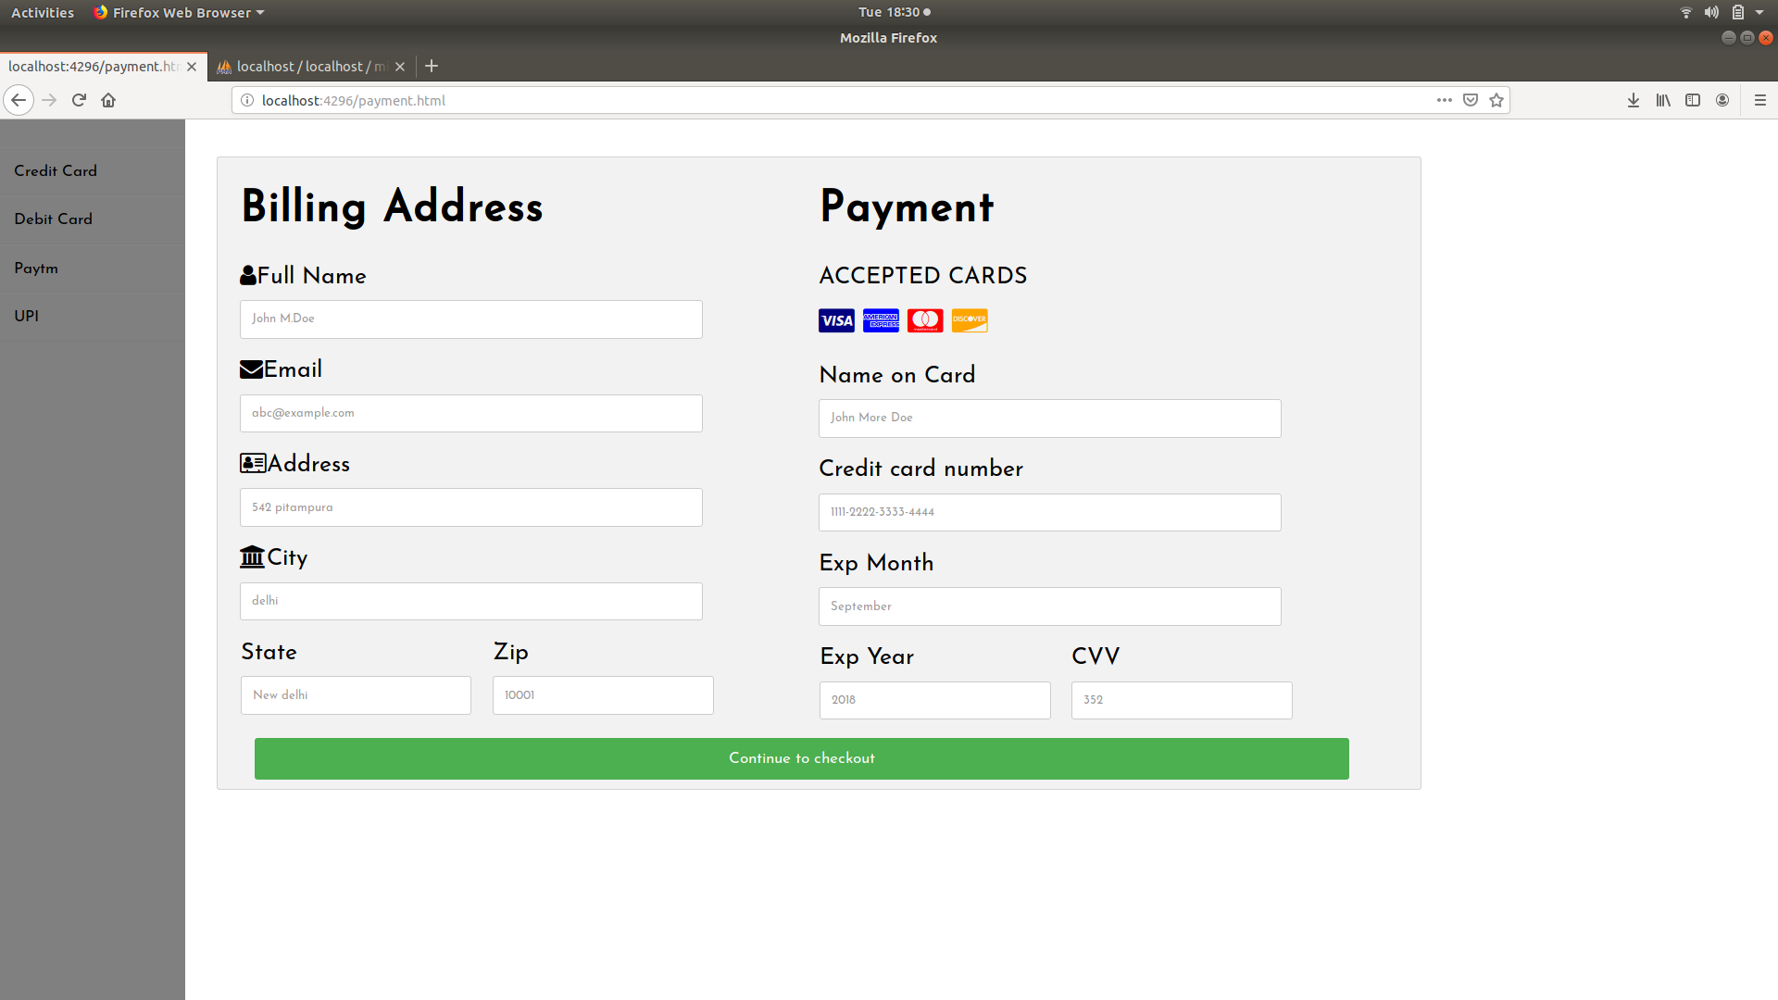

Fig 3.13 Payment methods for donation

**CHAPTER 4: CONCLUSION**

We have developed a Web-based application comprising of Web portal and secured database and identified exemplary students in primary education according to data (100%) uploaded and retrieved from several institutions and selected exemplary students is provided to the Education Department and NGOs.

All the educational institutions can upload the results of students as well as points/certificates of extra curricular activity (activity name, score out of 10 for performance) to the database for a student according to the current class of study. Aadhar number for all the students will always be given.

Admin can verify the data for the update in the database. Schools and institutions first login or registration and a unique token, (user id and password) is generated. That login is being further verified. So every institution has a unique user id and password and students' details are being uploaded yearly and updated.

Data is being sorted according to the merit of students. The designed application is performing the operation with the provided data and presenting a lesser (according to requirement) students' details.

Application is providing the list of exemplary students to the education department and NGOs. Each official and NGO has a dashboard. The list of exemplary students is being provided according to year, required field. Various NGOs based on the results can also donate and fund the education in particular schools.

**REFERENCES**

1. Jeffery C. Jackson, “Web Technologies - a computer science perspective” Edition 2008, Medium: English
2. “Database Management Systems” P. S. Gill. Edition 2008, Medium: English
3. Conference Paper at INCON VIII Volume: ASM's E journal of ongoing research in management and IT. Available: http://www.researchgate.net